2023 International Conference on
Advanced Control, Automation
and Robotics (ICACAR 2023)

Section 1: Basic Info.
Full name: |  | Affiliation:
Position: |  | Mobile:
Email: |  | Address:
Nationality: |  | Zip Code:

Section 2: Author Information
Paper ID: |  | Paper Pages: |  |  | Additional Page(s):
Paper Title:
Authors:
Will you attend the conference in person? |  |  |  | Yes No □
Presentation Terms √: |  | Oral □ Poster □ Remote Video Pre-recoreded Video □
Conference meal √: |  | Lunch □ Dinner □
Special requirement √: |  | Diabetic □ Vegetarian □ Halal Food □  Other □ (please specify: )

Section 3: Registration Fee
Onsite Conference
Category | HKSRA Member  (Full Paper) |  | Nonmember  (Full Paper) |  | Student  (Full Paper) | Presenter  (Abstract) | Listener
Early Registration  (Until Dec. 28) | USD 480 |  | USD 490 |  | USD 450 | USD 400 | USD 350
Regular Registration  (Until Feb. 28) | USD 490 |  | USD 530 |  | USD 480 | USD 450 | USD 350
Late Registration  (Until Feb. 28) | USD 530 |  | USD 580 |  | USD 490 | USD 480 | USD 350
On-site Registration  (April 14-16) | USD 580 |  | USD 610 |  | USD 550 | USD 500 | USD 400
Online Conference
Online Presentation | USD 390 |  | USD 420 |  | USD 380 | USD 300 | USD 200
Other
Extra Page / Per page | Extra Paper Upload |  |  | Extra Banquet Ticket |  | Academic Visit Optional
USD 70 | USD 370 |  |  | USD 50 |  | TBD
*One regular paper is within 5 pages, including all figures, tables, and references. Extra pages will be charged for Additional Pages Fee. The length of long paper should not exceed 14 pages.
*All accepted papers will be published on-line.
*Full Conference Registration Includes: Access to meetings sessions on April 14-16; Publication of one full paper; Free coffee breaks, lunch and dinner on April 15; Conference kits.
*For "No shows", registration fee is nonrefundable and the organizing committee shall not be liable for any compensation or refund.
*Cancellation Policy
If a registrant is unable to attend ICACAR 2023, they may substitute, by arrangement with the conference organizer, someone else to attend the conference, or transfer their participation to another conference in HKSRA conference portfolio. If the aforementioned solutions are not applicable to the registrant, the following policies of cancellation and refund apply.
- Up to 90 days prior to the conference date:
70% refund of the registration fees paid
- Less than 90 days, but more than 60 days prior to the conference date:
60% refund of the registration fees paid
- Less than 60 days, but more than 30 days prior to the conference date:
50% refund of the registration fees paid
- Less than 30 days prior to the conference date:
No refund
Please note: The cancellation and refund request must be made formally through email to email@icacar.org.
*Shall the conference is delayed or prevented (directly or indirectly) by the reasons of natural disasters, war, strike(s), epidemic or any other events which could not be controlled, the organizing committee shall be under no liabilities. The organizing committee reserves the right to change the conference date, venue or form of the conference (online or on-site).
Your Total Conference Fees:

PAYMENT INFORMATION
Please calculate the amount of your registration fee and finish the payment with Online Payment link: http://meeting.yizhifubj.com/web/main.action?meetingId=475
Notice
Please make sure the conference organizer, HKSRA’s logo is always appear on the page until you submit your payment information. Next you will be directed to the payment page.
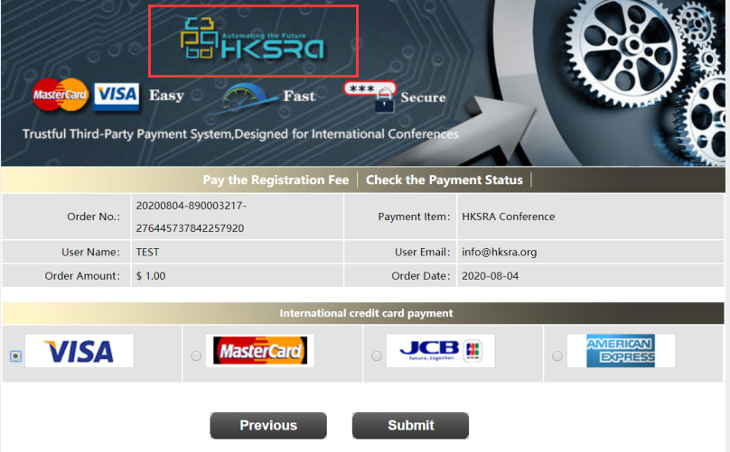
PAYMENT INFORMATION

Please fill in the following blanks after finishing your payment.
Payment Email:
Order No.:
Receipt Issued to:
Student ID No.(student only):
HKSRA Member No. (Member only):

Section 4: HKSRA Member
HKSRA MEMBER APPLICATION: Join HKSRA now to qualify for member registration rates.
Please compile and return the Membership Form along with your CV to membership@hksra.org. Your application will be processed in 5 working days.

Section 5: Other
Please provide your one-inch photo for conference use.

BIOGRAPHY:
You are encouraged to write down a biographical sketch here, for
the use of making introductions by Session Chair before your presentation.
20-120 Words(1-6.5 lines)
ng
Contact us through HKSRA LinkedIn for the latest news.
HKSRA LinkedIn

ICACAR 2023 Organizing Committee
Beijing

